Schedule of Events - This is Research: Student Symposium 2017

April 13th

Auburn University Student Center

8:00 a.m.
Continental Breakfast (Level 2 - beside rooms 2222 and 2223)
Registration (all day; Level 2 at entrance near room 2227)

8:00 a.m. – 12:00 p.m.
Oral Paper Sessions
(Level 2 - rooms 2216, 2218, 2222, 2225, 2227, 2310, 2326)

11:30 a.m. – 1:00 p.m.
Morning Poster Session
Networking Lunch
(Level 3 - Ballroom)

1:00 p.m. – 4:45 p.m.
Oral Paper Sessions
(Level 2 - rooms 2216, 2218, 2222, 2225, 2227, 2310, 2326)

4:30 p.m. – 6:00 p.m.
Afternoon Poster Session
(Level 3 - Ballroom)

Map of Auburn University Student Center
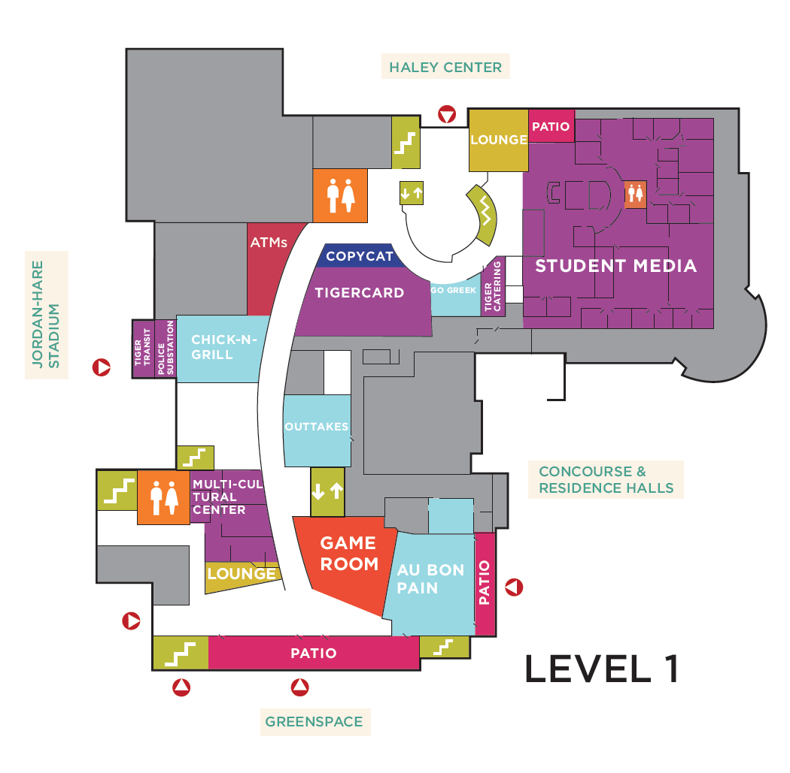
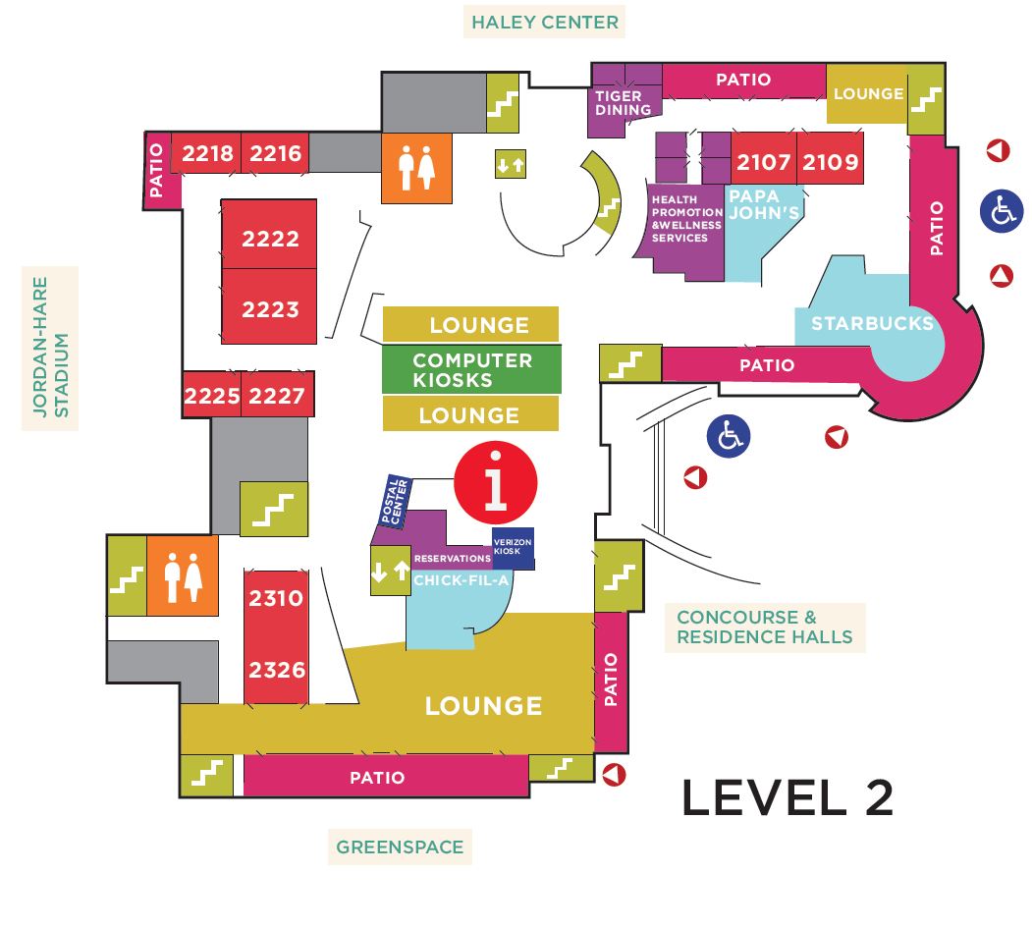

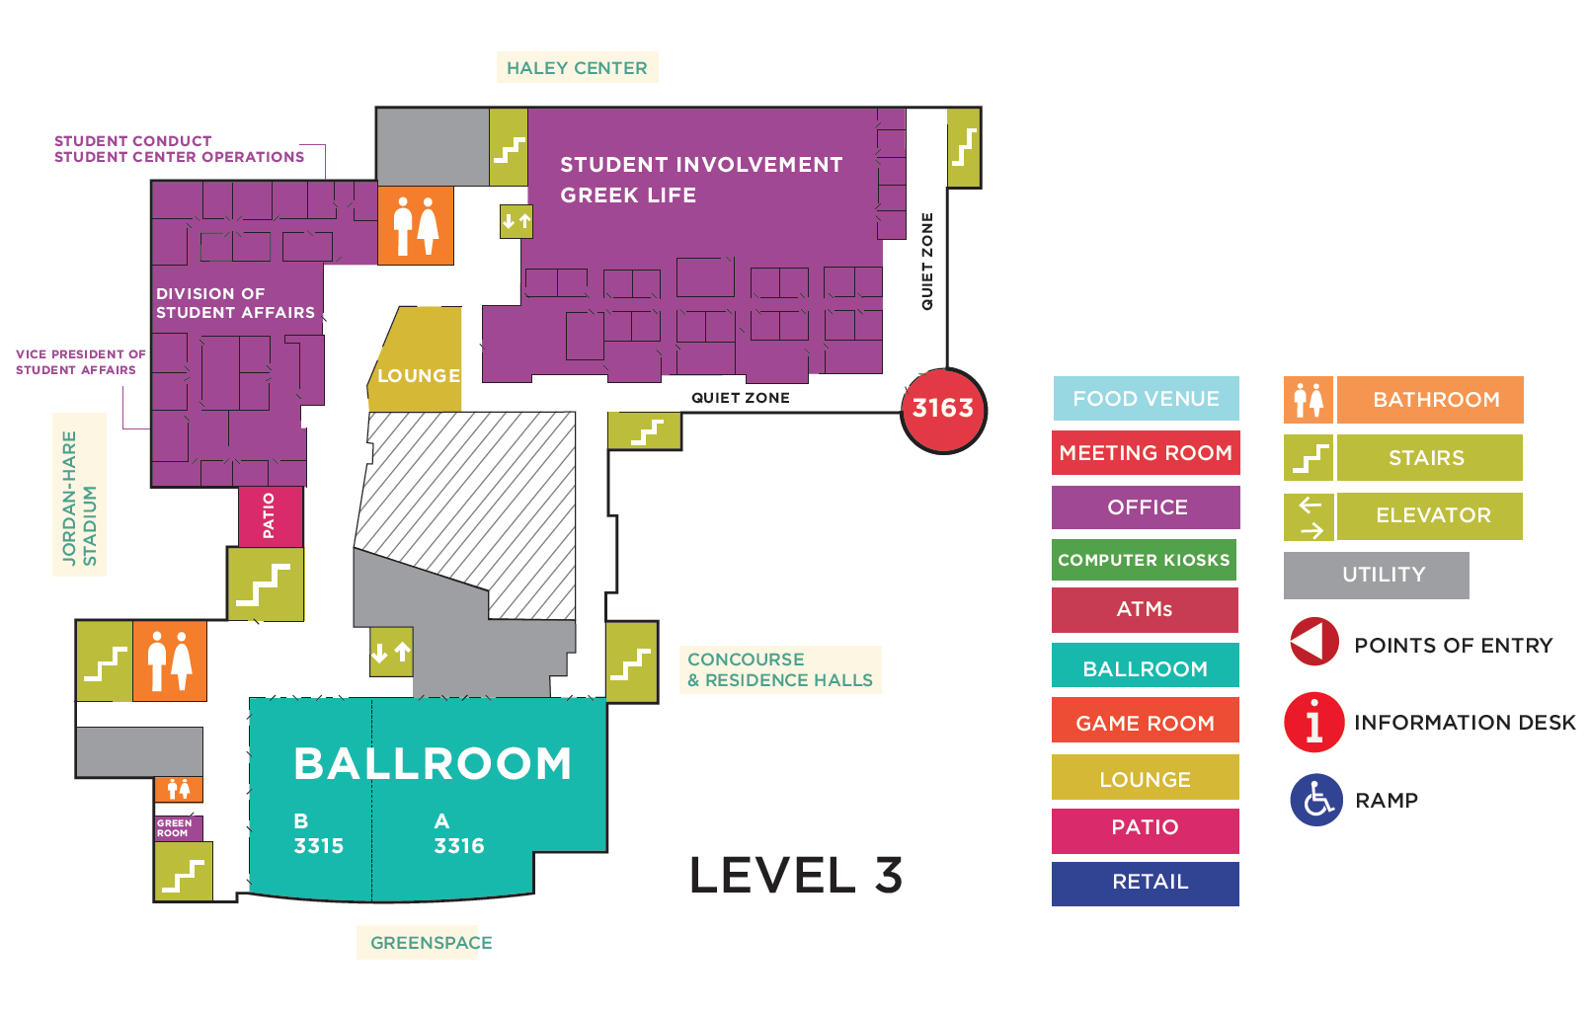

Oral Research Presentations – Morning Session
Student Center Meeting Rooms
8:00 – 8:45 a.m.

Room 2216 – Education/Communication
- Moss, Jackson (G) – Dress of the instructor in a lab setting
- Lin, Xi (G) – Achievement goal orientations and self-regulated learning strategies of adult and traditional learners
- Seung-Bickley, Rebecca (G) – Comparing credibility compliance of online health websites: An examination of pro- and anti-vaccination websites

Room 2218 – Poultry Science
- Smith, Avery (UG) – Evaluation of bioelectric impedance analysis to detect wooden breast myopathy from broiler breast fillets
- Patton, Samantha (UG) – Exploring magnetic resonance imaging technology for observing detectable differences of wooden breast
- Porter, J. Adam (G) – Effect of white mustard essential oil against Salmonella spp. In combination with carvacrol and thymol in vitro and in ground chicken

Room 2222 – Chemical Engineering
- Stone, Kyle (G) – Carbon and growth analysis of a methane consuming bacteria
- Hanley, Alan (G) – Characterization and self-assembly of Janus nanoparticles
- Tian, Yuan (G) – Peptide grafted poly(ethylene glycol) hydrogel support endothelial colony forming cells dynamic adhesion under fluid shear

Room 2225 – Psychology
- Schaefer, Megan (G) – Understanding Attention-Deficit/Hyperactivity Disorder (ADHD) medication self-management in college freshmen: Experiences, needs, and challenges
- Wagoner, Scott (G) – Examining a chronic illness as a possible protective factor for engagement in risky behaviors in a college sample
- Nuhu, Nadratu (G) – Evaluation of parent-child interaction therapy following functional analyses

Room 2227 – Agriculture/Animal Sciences
- Bennett, Katie (G) – Overseeding Eastern gamagrass with cool-season grasses or grass-legume mixtures
- Fike, Connie (G) – Nutritive quality of Coastal bermudagrass treated with plant growth-promoting rhizobacteria
- Gunter, Phillip (G) – Evaluation of nitrogen delivery methods for stocker cattle grazing annual ryegrass

Room 2310 – Biological Sciences
- Godwin, Rebecca (G) – Systematics of the genus Ummidia: species delimitation using natural history collections
- Josefson, Chloe (G) – Physiological and life history variation associated with reproductive performance across species of lab mice
- Alexandra Colombara (G) – Habitat segregation and population structure of coral reef sea anemones and symbiotic crustaceans

Room 2326 – Human Development and Family Studies
- Hlavaty, Kathleen (G) – Differentiating domestic violence exposure experiences in a young adult sample
- Savasuk, Rachel (G) – Understanding change in violence-related attitudes for adolescents in relationship education
- Cero, Ian (G) – Suicidal behaviour as a network of causally connected symptoms: A new strategy for prevention

9:00 – 9:45 a.m.

Room 2216 – Humanities and Art History
- Bewley, Shannon (UG) – The part and the whole: The multiple perspectives of Tara Donovan’s Untitled (Styrofoam Cups)
- Skjellum, Hannah (UG) – Reviving the mother of the blues: a continuation of the reconsideration of Ma Rainey as an important black queer figure
- Shipley, Kelsie (UG) – The unpublished Roman à Clef: private fiction and public figures at the turn of the 19th century in The Navy Officer

Room 2218 – Forestry and Wildlife Sciences
- Daniel, Marissa (G) – Utilization of phone app technology to record log truck movements
- Xu, Yecheng (G) – New mobility to sustainability: Herder and animal husbandry
- Devkota, Pratima (G) – Induced systemic resistance of Pinus taeda to Leptographium terebrantis and Grosmannia huntii by plant growth-promoting rhizobacteria

Room 2222 – Chemical Engineering
- Passantino, Joshua (UG) – Mechanical effects of PEO addition and flocculation on sheared cellulose nanocrystal films
- Preisser, Matthew (UG) – The role of knowledge in fostering international cooperation to better understand the environmental effects of marine renewable energy through the use of Tethys
- Kaczmarek, Jennifer (UG) – Direct production of human engineered cardiac tissues by pluripotent stem cell encapsulation in gelatin methacryloyl

Room 2225 – Fisheries
- Qin, Guyu (G) – Gene editing of the gonadotropin releasing hormone gene to sterilize channel catfish, Ictalurus punctatus, using a modified transcription activator-like effector nuclease technology with electroporation
- Cai, Wenlong (G) – Global transcriptional analysis of biofilm development by fish pathogen Flavobacterium columnare
- Burgos, Francisca (G) – Origin, composition, and diversity of the gut microbial communities in channel catfish Ictalurus punctatus

Room 2227– Mechanical Engineering
- Talebinezhad, Hossein (G) – Dielectric behavior and non-ohmic behavior of CCTO/SiO₂ composites
- Shrestha, Rakish (G) – Fatigue modeling of a thermoplastic polymer under mean strain and variable amplitude block loadings
- Pegues, Jonathan (G) – Influence of microstructure on crack initiation and microstructurally small crack growth of an austenitic stainless steel

Room 2310 – Entomology, Crop and Soil Sciences/Agricultural Economics
- Wang, Xiaodi (G) – Investigation of tick density, diversity, and pathogen prevalence among forested sites in east-central Alabama
- Harry, Brittany WITHDRAWN
- Chen, Rui (G) – Virtual water trade: Do bilateral tariffs matter?

Room 2326 – Biological Sciences
- Brasher, Adam (UG) – Does relative activity prior to breeding improve mitochondrial function and oxidative damage following a reproductive event?
- Prestridge, Laura (UG) – Parasite communities and diet of the Redspot Darter (Etheostoma artesiae) along a stream-size gradient
- Choi, Jiyeong (UG) – Patterns of Ni concentration among populations of the high-Ni insect Melanotrichus boydi (Hemiptera: Miridae), a specialist on the Ni hyperaccumulator plant Streptanthus polygaloides (Brassicaceae)

10:00 – 10:45 a.m.

Room 2216 – Forestry and Wildlife Sciences
- Lambert, Shannon (UG) – Evaluation of scents for baiting wild pigs
- Broadhead, Jordan (UG) – Does community conservation improve human and wildlife health?
- Rankins, Seth (UG) – High prevalence of Anaplasma platys infection in Alabama white-tailed deer

Room 2218 – Kinesiology
- Johnson, Jerraco (G) – Influence of high and low autonomy-supportive climates on physical activity in children with and without developmental disability
- Daou, Marcos (G) – Expecting to teach enhances motor learning and information processing during practice
- Edwards, Madison, and Montagner Sassi, Julia (G) – Cognitive and motor abilities in preschool children from low socioeconomic backgrounds

Room 2222 – Chemical/Computer Engineering
- Paul, Kyle (UG) – Nanoparticle surface characteristics impact in vitro cytotoxicity
- Pinkston, Jessica (UG) – Modelling pH dependent controlled drug delivery in contact lenses
- Liu, Tian (G) – An application of internet of things in chemical engineering

Room 2225 – Biological Sciences, Communication Disorders, and Drug Discovery
- Bauer, Eric (G) – Biodiversity patterns in upland streams of the southeastern US do not match the predictions of the Mighty Headwater Hypothesis
- Gould, Dianna Ting (G) – Myers-Briggs type indicator dichotomies as a predicator of hearing aid benefit in adult users
- Briggs, Gwyneth (UG) – SIRT3 agonists attenuate beta-Amyloid production in vitro through SIRT3-PGC1α-AMPK signaling pathway

Room 2227 – Fisheries
- Gratz, Steven (G) – Economic value of recreational fishing on reservoir and tailrace sections of Millers Ferry Reservoir, Alabama
- Abass, Nermeen Y (G) – Comparisons among channel catfish Ictalurus punctatus, blue catfish I. furcatus, and channel ♀ × blue ♂ hybrid catfish for growth, and salinity tolerance
- Jescovitch, Lauren (G) – Water quality and design of split-pond aquaculture

Room 2310 – Educational Foundations
- Huang, Mingyu (G) – Using danmaku in online lecture videos: An exploratory study
- Shi, Yuewei (G) – Teaching behaviours of international Asian professors
- Powell, Stephen (G) – Chronic stress and emotional regulation: A mixed methods analysis

Room 2326 – Mechanical, Electrical/Computer Engineering/Kinesiology
- Tucker, Zoe (UG) – The performance of translucent silicon-oxide nanoparticle lubricant additives
- Gilmer, Gabrielle (UG) – Effects of pain history on pitching mechanics in collegiate pitchers

11:00 a.m. – 12:00 p.m.

Room 2216 – Biosystems and Chemical Engineering
- Barde, Mehul (G) – Epoxy-novolac thermoset polymers based on pyrolytic bio-oil
- Bonts, Emily (G) – The observation of lined BioRetention cells as a closed system
- Saha, Partha (G) – Selective reflection of light from photonic cellulose nanocrystal coatings

Room 2218 – Social Sciences and Economics
- Gibbs, Corey (UG) – Fillipina immigration and identity
- Skuropat, Aislinn (UG) – Background checks and draft favorability in the NFL
- D, Bharat (G) – Dynamics of human capital accumulation, IPR policy, and growth
- Chen, Rui (G) – Banking crises and the performance of MIFs

Room 2222 – Nutrition
- Woodie, Lauren (G) – The influence of time-restricted feeding on diet-induced obesity, metabolic dysfunction and cognitive impairment
- Tumwebaze, Joel (G) – Evaluating the effectiveness of community gardening in reducing food insecurity and improving health in Chacraseca, Nicaragua
- Ahmed, Bulbul (G) – PDX (patient-derived xenograft) colon cancer tumor growth, morphology, and transcriptional profile in obese Rag1 mice

Room 2225 – Creative Scholarship
- Rolling, Virginia (G) – Wearable technology design development strategies
- DuPuis, Jenny Leigh (G) – Confluence
- Michaelson, Dawn and Gascon, Sarah (G) – Interdisciplinary Research: Improving Compression Garments for Women Athletes

Room 2227 – Mathematics and Computer Science
- Schloss, Elizabeth (UG) – Finding formulas for the number of pieces resulting from k (n-1)-dimensional linear cuts on a unit ball in euclidean n-space
- Kim, Doyon (UG) – Minimal spanning forests on infinite graphs
- Lindsey, Eddie (UG) – Effects of competition-mediated dispersal on the persistence of a population

Room 2310 – Polymer and Fiber, Industrial Systems, and Aerospace Engineering
- Teran-Somohano, Alejandro (G) – The facility layout problem in healthcare: New models and methods
- Joshi, Prutha (G) – Preparation of slow release encapsulated pesticide/fertilizer
- Ramesh Kumar, Tharikaa (G) – Biglobal instability of compressible Taylor-Culick Solution in solid rocket motors

Room 2326 – Biomedical Sciences
- Hightower, Harrison (UG) – Establishing the neuroprotective effects of Hibiscus sabdariffa
- Selby, Katherine (UG) – The process of meta-analysis
- Robinson, Anna (UG) – Anti-carcinogenic and complementary effects of Viscum album canine glioblastoma cell lines

Morning Poster Session
Student Center Ballrooms
11:30 a.m. – 1:00 p.m.

Nursing (Section A)
- Barganier, Sharon (G) – Examining telehealth monitoring for heart failure patients and the effects in hospital admissions and readmissions
- Lesniak, Andrea (G) – Improving heart failure management with improved self-care behaviors
- Ledbetter, Laura (G) – Improving self-management of heart failure through enhanced heart failure education
- Morris, Alicia (G) – Multidisciplinary approach in diabetic patients
- Duke, Morgan (G) – Cardiovascular disease: Risk factor reduction and prevention in women
- Gorman, Loren (G) – Provider communication and education for reduction of antibiotics in upper respiratory infections (URI)
- McDonald, Whittni (G) – Improving adult vaccination rates in primary care
- Lovvorn, Melissa (G) – The importance of education on a healthy lifestyle for diabetic or at risk adolescents
- Leger, Ashton (G) – Evidence-based practice project: elective induction of labor
- Scully, Lisa (G) – Increasing breastfeeding rates
- Parker, Jessica (G) – Skin-to-skin education among women of childbearing age
- Baker, Heather (G) – Kangaroo care education
- Davis, Erin (G) – Stethoscope decontamination
- Smith, Jenny (G) – Diabetic education in perioperative services
- Litwiller, Kimberly (G) – Improving teen diabetic education through parent and peer support
- Overby, Regan (G) – Improve medication adherence in type II diabetes through teach back and pictorial image
- Santana, Grace (G) – Smoking cessation for parents of children with asthma
- Wolff, Melissa (G) – Diabetic self-management education in the primary care setting using the chronic care model
- McDonald, Brittni (G) – Smoking cessation in people with type 2 diabetes mellitus
- Dixon, Kenyetta (G) – Introducing mobile technology to adults with type II diabetic for self-management
- Parker, Magan (G) – Treating diabetic foot ulcer infections with evidence based practice
- Mason, David (G) – Uncomplicated skin and soft tissue infections
- Vuc, Iulian (G) – Primary care management of heart failure patients: reducing 30-day readmission rate
- Kakish, R., Kitchens, C., Mokry, M., Robinson, A., Smith, F. (UG) – Breastfeeding education outcomes
- Gandy, T., Godfrey, T., Lang, M., Costa, M.S. (UG) – Nursing interventions for decreasing neonatal pain
- Cohen, K., Cowen, C., Smith, S., Vincent, E. (UG) – Rub-a-dub-dub: keep newborns out of the tub
- Anglin, R., Berkebile, E., Pope, M., Sanchez, Z. (UG) – Two preemies in a pod: the impact of co-bedding on premature twins
- Floyd, T., Hornsby, S., Owen, C., Speck, S. (UG) – Glycemic control to combat complications in surgical patients with diabetes
- Ashley, S., Caton, H., Patel, M., Williams, R. (UG) – Effects of animal -assisted therapy on quality of life
- Barnett, A., Fullerton, C., Guy, G., Price, C. (UG) – Alarm fatigue among acute care nurses
- Deleon, A., Gay, G., Seay, A., Thompson, G. (UG) – Effect of daily family visitation on nicu patient's length of stay
- Browning, E., Hess, H., Jackson, J., Lashley, T. (UG) – Pre-procedure education for pediatric patients

Chemical Engineering (Section B)

#1-5 will present from 11:30 AM- 12:30 PM #6-8 will present from 12:00 PM- 1:00 PM
- Cullum, Richard (G) – Screening methodologies for the discovery of targeted melanoma therapeutics
- Whitener, Ricky (G) – Development and characterization of DNA aptamers targeting Small Cell Lung Cancer cells
- Minkler, Michael (G) – Impact of microstructure on physical and optoelectronic properties of polyalklythiophenes
- Dobyns, Breanna (G) – Determination of solute permeabilities and membrane selectivities through copolymer membranes via in situ ATR FTIR spectroscopy
- Ellis, Morgan (G) – Encapsulation of patient-derived pluripotent stem cells to study congenital heart disease
- Ray, Gannon (UG) – Liposomes and gold nanoparticles: investigating and quantifying targeted drug delivery
- Head, Sarah (UG) – 3D-printed molds to provide shape variability in hydrogel scaffolds for engineered human cardiac tissues
- Davis, Montoia (UG) – Drug delivery mechanism of sulfathiazole from polyurethane films

Forestry and Wildlife Sciences (Section C)

#1-7 will present from 11:30 AM- 12:30 PM #8-15 will present from 12:00 PM- 1:00 PM
- Iglesias, Maria (G) – Residual lignin and its effect on the rheological properties cellulose nanofibrils suspensions
- Tormanen, Aaron (G) – A cost-effective method for canine heartworm surveillance
- Xu, Rongting (G) – Global ammonia emissions from synthetic nitrogen fertilizer applications in agricultural systems: empirical and process-based estimates and uncertainty
- Daniel, Marissa (G) – Utilization of Phone App Technology to Record Log Truck Movements
- Zikeli, Shelby (G) – A methods comparison of ectoparasite quantification in white tailed deer (Odocoileus virginianus)
- Sanchez Diaz, Simon (G) – Morphological study of the electrospinning process parameters over the structure of silk fibroin nonwoven performed at low concentrated solutions
- Gonnerman, Matthew (G) – Estimating occupancy, density, and productivity of eastern wild turkeys in Alabama
- Mensah, John (G) – Effect of Leptographium terrebrantis on tree physiology and growth of loblolly pine
- Zenas, Stephen (G) – Factors influencing survival and capture-related morality of Eastern wild turkeys in Alabama
- Duwadi, Sharijana (G) – Study of soil microbial biomass and soil moisture in loblolly pine stand
- Finney, Micaela (UG) – Feeding preferences of malaria vectors in Madagascar
- Kallenberg, Marie Christine (UG) – Change in the lipid transport capacity of the liver and blood during reproduction in rats
- Long, Brandon (UG) – A shell of a good time: quantifying box turtle detection probability in an urban landscape
- Miller, Madison (UG) – Assessing the economic costs of managing invasive species across the United States
- Baxter, Tyler (UG) – Evaluating the effectiveness of prescribed fire to restore longleaf-slash pine ecosystems

Drug Discovery and Pharmacy (Section D)

#1-7 will present from 11:30 AM- 12:30 PM #8-13 will present from 12:00 PM- 1:00 PM
- McLeroy, Jordan and Jesse (UG) – Plants used for maternal and women’s health by indigenous populations in Panama: a review
- McLendon, Lane (UG) – Evaluation of inhibitory effect of Maca on CYP3A4 liver enzyme
- Anderson, Joseph (UG) – Elucidate the mechanisms of action of the Tri-Fluoro-Methyl-Phenyl-Piperazine derivatives
- Bergstresser, Sydney (UG) – Identifying RECQL breast cancer variants in an Alabama cohort
- Lynd, Tyler (UG) – The comparative effects of honokiol and pioglitazone on mitochondrial function in an in vitro Alzheimer’s disease model
- Adamek, Danielle (UG) – Novel PPAR-gamma agonist improve pathology and memory deficits in a 3xTg-Ad mouse model of Alzheimer’s disease
- Brazelle, Morgan (UG) – Tracking of Staphylococcus aureus infections through bioluminescence and IVIS MiSpinner
- Wesolowski, Alec (UG) – Multispectral opto-acoustic tomography provides a potential non-invasive method of tracking infections in vivo
- Jung, Da Sol (UG) – Identification of phase I & phase II metabolites of maca
- Cimino, Addison (UG) – Towards the synthesis of a functionalized cycloparaphenylene
- Wyss, Kevin (UG) – Solid-state napthylsalophen actinide complexes and rare thorium fluorescence
- Valentine, Kate (UG) – Uranyl sensing using quinoxalinol salen-based ligand
- Boothe, Robert (UG) – Nickel(II) complexes with quinol-containing ligands as redox-responsive PARACEST agent

Anatomy, Physiology, Animal Sciences, and Poultry Sciences (Section E)

#1-4 will present from 11:30 AM- 12:30 PM #5-8 will present from 12:00 PM- 1:00 PM
- Heslin, Ryan (G) – Peripherally restricted viral mimic impairs learning and memory in a fear conditioning paradigm
- Hagerty, Samantha (G) – Metal nanoparticles obtained from olfactory and respiratory epithelia enhance olfactory responses to odorants
- Fang, Han (G) – Niacin improves gut function and microbiota composition in high-fat diet fed mice
- Escaro, Sarah (G) – In vitro measurements of friction of intact equine articular cartilage against various surfaces
- Yuan, Jing (G) – Survival of Escherichia coli O157:H7, Salmonella spp., and Listeria monocytogenes on the skin and sliced kiwifruit
- Turner, Stephanie (G) – Changes in in vitro fermentative capacity of equine feces due to alteration of forage diet
- Wassel, Brooklyne (G) – Solubilization of nonstructural carbohydrates as a function of soaking interval and water temperature in southern forages commonly fed to equids
- Rubio, Andrea (G) – Effects of micro pellets during the starter period on performance and carcass characteristics of broilers

Educational Foundations (Section F)

#1-3 will present from 11:30 AM- 12:30 PM
- Finnegan, Vanessa (G) – Do first year engineering students identify as future engineers? Explorations in occupational identity
- Benbaba, Asmaa (G) – Building relationships, accessing resources and creating a context for community based learning in community garden
- Askia, Rashida (G) – The effect of reduced barriers on remedial and college-level math success

Audiology (Section G)

#1-5 will present from 12:00 AM- 1:00 PM
- Armstrong, Molly (G) – Characterization of noise levels and auditory function in students at auburn university football games
- Moore, Whitney (G) – Effects of sound recover feature on speech intelligibility in noise in new hearing aid wearers
- Turnbough, Abby (G) –The choice of musical instrument and its effects on auditory working memory and perception in adolescents
- Hanson, Meaghan (G) – Pediatricians role and knowledge of universal newborn hearing screening, diagnosis, and protocols
- Bannon, Hannah (G) – Does cooperation increase when music is used in the care of people who have dementia?

Civil Engineering and Building Science (Section H)

#1-7 will present from 11:30 AM- 12:30 PM #8-9 will present from 12:00 PM- 1:00 PM
- Tutu, Kenneth (G) – Nondestructive determination of asphalt pavement crack type
- Tian, Shuting (G) – The contact toxicity of essential oils to the house fly (Musca domestica)
- Xu, Dan (G) – Impact of deceleration lane length on vehicles’ speed and deceleration rates based on NDS data
- Atiquzzaman, Md (G) – Geometric design characteristics of exit ramp terminals with confirmed wrong-way entries
- Gilbert, Claire (G) – Applying radio frequency identification tags to improve personnel safety in dredging construction
- Bell, Matthew (G) – The development of sustainable walls for a steel framed house for developing countries
- Huffines, Trenton (G) – Implementing housing design and construction for communities in Panama
- Walsh, Mark (G) – WITHDRAWN
- Martin, Douglas (G) – An analysis of suitable materials for use in tiny home construction

Chemistry, Biochemistry, Animal Sciences (Section I)

#1-2 will present from 11:30 AM- 12:30 PM #3-4 will present from 12:00 PM- 1:00 PM
- Ariyaratha, Isuru (G) – Oxygen unveils the versatile personality of beryllium: The case of BeOn=1,2,4
- Rajakaruna, Pradeepa (G) – Oxidation of cysteine sulfinic acid by bis(1,4,7-triazacyclononane)Ni(III)
- McCormack, Kaylee (UG) – 1-Thia-3,4-Diazolidine-2,5-dione polymers
- Willhelm, Gabby (UG) – Evaluating developmental effects of a single follicle culture system and granulosa cell biopsies on fertilized cumulus-oocyte-complexes

Social Science, Anthropology, and Economics (Section J)

#1-3 will present from 12:00 PM- 1:00 PM
- Harrell, Crystal (UG) – Reconstructing post-emancipation communities through the preservation of African American cemeteries
- Odabasi, Suzan (G) – Alcohol consumption and crime: A panel study of South-eastern counties in the USA
- Rolling, Virginia (G) – A cross-cultural perspective on additive manufacturing

Architecture, Planning, and Landscape Architecture/Environmental Design (Section K)
#1-6 will present from 11:30 AM- 12:30 PM #7-10 will present from 12:00 PM- 1:00 PM
- Shakya, Looja (G) – The hydrological cycle
- Wang, Rui (G) – Creating an urban park linking Chattahoochee River and downtown Columbus, GA
- Kaaur, Jaspuneet (G) – SURGE: integrating edible plants in urban landscapes
- Hamrick, Rachel (UG) – Challenging plaster’s intrinsic properties through analog and digital modeling
- Porter, Allison (UG) – Urban Poverty
- Carlin, Margaret (UG) – conGRADulations!
- Ossenfort, Christian (UG) – Powering the future
- Souders, Lindsay (UG) – Quantify the effects of ocean pollution
- Keel, Benjamin (UG) – The lack of skilled labor and vocational education
- Vawter, Anna (UG) – Increasing urban well-being through introduction of moveable chair

Biosystems Engineering (Section L)

#1-6 will present from 11:30 AM- 12:30 PM #7-12 will present from 12:00 PM- 1:00 PM
- Jiminez-Bonilla, Pablo (G) – Study of the role of two alcohol dehydrogenase enzymes on bio butanol production in Clostridium beijerinckii
- Patil, Bivek (G) – Hydrothermal liquefaction of lignin for production of biofuels and chemicals
- Shakya, Rajdeep (G) – Catalytic upgrading of bio-oil produced from hydrothermal liquefaction of algae in mixtures of supercritical carbon dioxide and hydrogen
- Rubisch, Mary Catherine (G) – Effect of guar on removal and treatment of catfish waste
- Wang, Pixiang (G) – Biomass pretreatment with acetic acid for acetone-butanol-ethanol (ABE) fermentation
- Litton, Garrod (G) – Benthic algae cultivation for recovery of nutrients from aquaponics wastewater
- K C, Sanjeev (G) – Understanding the effect of catalytic pyrolysis bio-oil produced using CaO during hydrotreatment
- Sajib, Sourov Kar (G) – Biomass derived nitrogen-doped hierarchical porous activated carbons for lithium-sulfur battery
- Li, Kaiyan (UG) – Investigating the impacts of Bacillus on green algae metabolism
- Granger, Craig (UG) – How stream restoration affects in-stream ecological metabolic activity
- Bankston, Elizabeth (UG) – Following the mass flow of nitrogen throughout an aquaponics system
- King, Benjamin (UG) – Comparing the floodplain hydrology of a recently restored stream bank to a natural, undisturbed, floodplain

Psychology (Section M)

#1-5 will present from 11:30 AM- 12:30 PM #6-12 will present from 12:00 PM- 1:00 PM
- Travis, Allison (UG) – The effect of drawing on information consolidation and stress reduction
- Britton, Erica (UG) – Work-life enrichment and work outcomes: A meta-analysis
- Bovee, Meredith (UG) – Associations of trauma, victimization patterns, and aggression during adolescence
- Slife, Sarah (UG) – Affective states and role overload: The moderating effect of integration
- White, Shelby (UG) – Variations in disclosure experiences among young adults exposed to domestic violence
- Nuhu, Nadratu (G) – Functional behavior assessment of parents’ nonadherence to behavior intervention plans
- Young, Margaret (G) – Comparison of quality of life ratings in young adults with ADHD across various chronic conditions
- Paneerselvam, Bavani (G) – Disruption of the relational and item-specific processing supports the negative outcomes of multiple-choice testing with additional lures
- Haygood, Sarah (G) – Effects of intensity and spacing of problem behavior on levels of treatment integrity
- Lorys, Anna (G) – The effects of maximizing decision styles on perceptions of work-life balance
- Ritterbush, Elizabeth (G) – The dark side of ethical decision making
- May, Viola (G) – An examination of job satisfaction and work-life balance among racial minority faculty in higher education

Entomology and Horticulture (Section N)

#1-3 will present from 11:30 AM- 12:30 PM #4-10 will present from 12:00 PM- 1:00 PM
- Zhang, Xinmi (G) – Investigating the vector(s) of epizootic hemorrhagic disease virus in Alabama
- Tian, Yuexun (G) – The contact toxicity of essential oils to the house fly (Musca domestica)
- Ajayi, Olufemi (G) – Comparative water relations and desiccation tolerance of four invasive ant species
- Chen, Hongyu (G) – The outer membrane protein MopB is associated with biofilm formation, twitching motility and virulence of the plant pathogen Xylella fastidiosa
- Hassan, Mohammad (G) – Efficiency of pectin supplement in root colonization and plant growth-promotion of soybean plants by Bacillus velezensis
- Morawo, Tolulope (G) – Only a fraction of host-associated odor blend mediates attraction in parasitoids
- Till, Stephen (G) – An integrated approach to improving corn plant health in Meloidogyne incognita infested fields with nematicides, plant growth regulators, and starter fertilizers
- Dyer, David (G) – Biological pathogen of Heterodera glycines, Rotylenchulus reniformis, and Meloidogyne incognita
- Xie, Lingbo (G) – Impact of harvest maturity on consumer preference, fruit quality, and postharvest longevity of two kiwifruit cultivars (Actinidia chinensis Planch.)
- Kargar, Mahnaz (G) – Carotenoid accumulation in peel and pulp tissues of genomically diverse banana cultivars in Southeastern United States

Kinesiology (Section O)

#1-3 will present from 11:30 AM- 12:30 PM #4-7 will present from 12:00 PM- 1:00 PM
- Rhoades, Jence (G) – Examining a motor learning paradigm: To teach or not to teach
- Dyke, Ford (G) – Effects of 'green’ stimuli neurocognitive function: An ERP study
- Gordon, Sarah (UG) – The effect of whole body vibration on stress fracture healing
- Camp, Peyton (UG) – Understanding engagement and motivation in learning a complex motor skill
- Clardy, Kathryn (UG) – Kinematics of youth baseball pitching and football passing
- Meagher, Mallory (UG) – Cardioprotection of HIF-1 Frataxin against ischemia reperfusion injury in diabetic myocardium
- Gilmer, Gabrielle (UG) – Influence of Postural Compression Garment on Scapular Muscle Activation

Oral Research Presentations – Afternoon Session
Student Center Meeting Rooms

1:00 – 1:45 p.m.

Room 2216 – Physics
- Vaughan, John (G) – Generation of the first attosecond pulses in the state of Alabama
- Kring, James (G) – Impurity studies in fusion research on Wendelstein 7-X
- Johnson, Curtis (G) – Improving spectral diagnosis of erosion during plasma material interaction to assess the potential of fusion energy as a future energy source

Room 2218 – Psychology
- Yanes, Julio (G) – Dissociable meta-analytic networks contribute to post-traumatic stress disorder (PTSD)
- Luna, Odessa (G) – Evaluating the effectiveness of and preference for peer vs. supervisor feedback
- Lazarowski, Lucia (G) – Responsiveness to humans generalizes across problem solving in dogs

Room 2222 – Poultry Sciences
- Liao, Chao (G) – Evaluation of microbiome present in bagged Spring mix salad
- Johnson, Meredith (G) – Carcass aging as a potential solution for tough meat quality issue in modern broilers
- Qiao, Mingyu (G) – Modifying food contact surfaces with N-Halamine for antimicrobial properties

Room 2225 – Humanities and Political Science
- Zinner, Max (G) – A spirit that is not afraid: Gay and lesbian rights at Auburn University 1990-1991
- Crayton, Mac-Jane (G)– Gender in leadership in non-profits: Female leadership deficit in nonprofit sector

Room 2227 – Forestry and Wildlife Sciences and Geosciences
- Cole, Andrea (G) – Competitiveness of Amylostereum spp. fungi against Leptographium spp. fungi
- Clements, Allen (G) – Geochemical analysis of the karstic Bobcat Cave watershed: A case study in Northern Alabama
- Haines, Angelina (G) – Factors influencing fire ant prevalence and nest predation on grassland birds in a fire-mediated ecosystem

Room 2310 – Kinesiology and Nutrition
- Gascon, Sarah (G) – Biomechanical influences of a postural compression garment on scapular positioning
- Mukigi, Dorcas (G) – Prevalence of food insecurity among students enrolled at Auburn University, Alabama
- Wyatt, Chris (G) – Diabetic dyslipidemia: Efficacy of diabetes self-management education and medical nutrition therapy

Room 2326 – Civil Engineering
- Wang, Jin (G) – In-depth investigation of wrong-way crashes on divided highways in Alabama using Haddon Matrix and field observations
- Xue, Chennan G) – Evaluate in-cab sound and vibration generated by directional rumble strips for deterring wrong-way freeway entries
- Tankasala, Aravind (G) – Investigating the behavior of lightweight aggregates in mass concrete

2:00 – 2:45 p.m.

Room 2216 – Fisheries
- Wang, Xiaozhu (G) – Multiple across-strain and within-strain QTL suggest highly complex genetic architecture for hypoxia tolerance in channel catfish
- Bart, Ryan (G) – Distribution and abundance of pelagic fishes in Southeastern US reservoirs containing blueback herring
- Odin, Ramjie (G) – Identifying elite parents of channel catfish (Ictalurus punctatus) female x blue catfish (I. furcatus) male F1 hybrid progeny with superior performance traits using combining ability analysis

Room 2218 – Crop, Soil, and Environmental Science
- Duan, Yanan (G) – Enhancing lake inflow forecasts in the Alabama-Coosa-Tallapoosa (ACT) River Basin using the North American multi-model ensemble
- Lin, Yaru (G) – Influence of poultry litter and double cropping on soybean yield
- Jiang, Tao (G) – Association mapping of SSR markers to sweet, bitter, and roasted peanut sensory attributes in cultivated peanut

Room 2222 – Chemical Engineering
- Finklea, Ferdous (G)– Manufacturing functional engineered cardiac tissue spheroids using a custom microfluidic system
- Kelly, Jessica (G) – Evaluation of enzyme-loaded nano-polymersome treatment on neurodegenerative GM1 gangliosidosis
- Hand, William (G) – Soy protein substitution in phenol formaldehyde adhesive used in oriented strand board

Room 2225 – Pathobiology and Animal Sciences
- Eldemery, Fatma (G) – Improved protection against infectious bronchitis virus by including S2 ectodomain in subunit vaccine
- Read, Casey (G) – Analysis of Cx43 gap junctional coupling and ATRA signalling and their relationship to embryo development in Bos Taurus
- Yuan, Jing (G) – Comparison of different enumeration protocols for indicator microorganisms in water and sediment

Room 2227 – Industrial and Systems Engineering
- Ahady Dolatsara, Hamidreza (G) – Developing a dynamic tool for transplant survival analysis
- Sedighi Maman, Zahra (G) – A data-driven approach to modeling physical fatigue in the workplace using wearable sensors
- Kim, Kyongsun (G) – Pricing real options premium based on the Conditional Value at Risk (CVaR) concept

Room 2310 – Chemistry, Biomedical Sciences, and Veterinary Medicine
- Gohlke, Madison (UG) – Comparison of a point-of-care glucometer (POCG) and an automated biochemical analyzer to measure glucose concentrations in whole blood, serum, and plasma from porcine blood samples
- Singletary, Melissa (G) – Polyethylene coated of zinc nanoparticles maintain capable of enhanced olfaction
- Hardy, Emily (G)– Pyridine containing soft donor ligands for molecular recognition of uranyl: Nuclear contamination detection via color change

Room 2326 – Consumer and Design Sciences
- Rashid, Md Sanuwar (G) – Country of origin and fair trade message: The impact of hangtag information on brand evaluation
- Levinson, Emily (G) – Preparing for specialized practice in design and wellness: A model curriculum
- Rolling, Virginia (G) – Millennials’ impression of luxury goods manufactured using recycle materials

3:00 – 3:45 p.m.

Room 2216 – Fisheries
- Gosh, Kamal (G) – Analyzing the economic impact of growth variability on the channel-blue hybrid catfish production
- Tucker, Rebecca (G) – Warming temperatures lead to respiratory stress and brood expulsion by gravid mussels
- Novriadi, Romi (G) – Improvement of soy based diet efficiency for Florida pompano Trachinotus carolinus L by using combination of advance soybean and squid products

Room 2218 – Hospitality Management
- Chen, Han (G) – Econometric modeling of the U.S. hotel industry revenue
- Bernard, Shaniel (G) – Consequences of hotel green washing: The moderating effect of customer’s previous experience
- Brown, Katie (UG) – Researching food insecurity at Auburn University

Room 2225 – Drug Discovery and Development
- Chandler, Madison (G) – Insights from gene panel screening using a newly established Alabama cancer cohort
- Porter, Haley (G) – Improved retention of nepafenac on the ocular surface for sustained drug delivery
- Watkins, Anna (G) – Sequencing canines with mammary tumours to identify hereditary breast cancer genetic risk variants

Room 2227 – Civil Engineering
- Ayers, Meredith (UG) – Mineralogy determination via three-dimensional image analysis
- Xie, Zhaoxing (G) – Evaluation of foamed warm mix asphalt with reclaimed asphalt pavement: Field and laboratory experiments
- Wu, Hongyang (G) – Effect of vertical accelerations on steel frame structures

Room 2310 – Chemistry and Biochemistry
- Brown, Matthew (UG) – Elucidation of the heme d₁ biosynthetic pathway in Paracoccus denitrificans
- Fujihashi, Ayaka (UG) – Evaluation of the hippocampal associated neurotoxic effects of prenatal alcohol and nicotine exposure in rodents
- Bartlett, Abigail (UG)– Evaluation of substrate specificity in the two-component alkanesulfonate monooxygenase system

Room 2326 – Electrical Engineering
- Yelamanchili, Bhargav (G) – Adhesion between polyimide films and thin metal films
- Prather, Craig (G) – Design of a novel airborne atmospheric sensor
- Smith, James (UG)– Improvements for special neural network architectures

4:00 – 4:45 p.m.

Room 2216 – Forestry and Wildlife/Biological Sciences
- Sharma Dangal, Shree Ram (G) – Global impacts of grazing on vegetation and soil organic carbon during 1901-2010: A process-based modelling study
- Lewis, Alexandra (G) – Beavers are engineers; trees are not: The dam truth
- Weber, Jennifer (G) – Morphology of introduced populations of Orconectes virilis (Decapoda, Cambaridae) is dependent on habitat

Room 2218 – Nutrition, Dietetics, and Hospitality Management
- Chen, Han (G) – Investigating the influence of workplace fun and humor on hospitality employees’ selected work outcomes
- Griffin, Jamie (G) – Effectiveness of My Quest, an intervention using text messaging to improve dietary and physical activity behaviors and promote weight loss in low-income women in Alabama
- Salazar, Maria (G) – A multisite study demonstrating the efficacy of diabetes self-management education and medical nutrition therapy in the management of Type 2 diabetes in Alabama

Room 2222 – Biosystems Engineering
- Harun, Khalida (G) – Comparative studies of Ru-doped ZSM-5 and activated carbon for hydrogen production by thermocatalytic decomposition of methane
- Zhang, Zhongtian (G) – In situ esterification and extractive fermentation for butyl butyrate production with Clostridium tyrobutyricum
- Dong, Sheng (G) – Metabolic engineering of Bacillus and Clostridium for 2-butanol production

Room 2227 – Chemical Engineering
- Kelly, Alexander (G) – Nanoparticle supported membranes for drug delivery
- Noor, Matthew (G) – Rheo-optical investigation of liquid crystalline double-stranded DNA and single walled carbon nanotube dispersions
- Hansford, Andre (UG) – The effects of pH on aqueous cellulose nanocrystal dispersions’ rheology and phase behavior

Room 2310 – Drug Discovery and Development
- Spina, Stephanie (UG) – Sequencing miRNA clusters for the identification of BC genetic risk variant
- Shepp, Kasey (UG) – The effect of rare variants of hydroxy-carboxylic acid receptors on hereditary breast cancers
- Fahoury, Eddie (UG)– Anti-inflammatory and immunomodulatory activities of Scutellaria lateriflora

Afternoon Poster Session
4:30 – 6:00 p.m.
Student Center Ballroom

Physics (Section P)

#1-4 will present from 4:30 PM- 5:30 PM #5-6 will present from 5:00 PM- 6:00 PM
- Wang, Martin (UG) – Role of carotenoids as antioxidants in Tigriopus californicus
- Harrison, Geoffrey (UG) – A code to retrieve the three-dimensional photolectron emission from a two-dimensional image
- Kish, Ayden (UG) – Dust particle circulation and vortices in a dc glow discharge dusty plasma
- Hidle, Brock (UG) – Development of Frequency Resolved Optical Gating (FROG) technique for characterization of femtosecond pulses
- Lopez Ortiz, Omar (G) – High-beta analytic equilibria in circular, elliptical and d-shaped large aspect ratio axisymmetric configurations with poloidal and toroidal flows
- Jayawardena, Asanka (G) – Development of 4H-SiC trench electronic device

Nursing (Section Q)
- Clemons, DeLana (G) – Preventing the progression of pre diabetes to diabetes
- Kilcrease, Melissa (G) – Home-based cardiac rehabilitation: Determining feasibility among rural residents
- Lawson, Stephanie (G) – Decreasing cardiovascular disease risk factors with family-based interventions
- Robinson, Cynthia (G) – Medication adherence in patients with bipolar disorder
- Lemon, Megan (G) – Strategies for lifestyle modifications for blood pressure control
- Popp, Chelsea (G) – Safeguards to reduce polypharmacy in the older adult
- Wilson, Bridget (G) – Diabetes education: Producing quality outcomes through knowledge and self-management
- Skaug, Shannon (G) – Yoga as a complementary therapy for type II diabetes management
- Goodson, Amanda (G) – Tobacco cessation: improving the outcomes
- Young, Brian (G) – Preventing readmission in patients with congestive heart failure
- Crane, Adrianne (G) – Improving diabetic outcomes through a peer coaching telephone communication intervention in the primary care setting
- Jones, Brandi (G) – Increasing venous thromboembolism through education
- Faison, Sarah (G) – The use of honey-impregnated dressings in the treatment of chronic wounds
- Barksdale, Whittnye (G) – Promoting antibiotic stewardship in pediatric patients
- Morris, Mary (G) – Educating nurses on the Braden Q scale
- Walker, Brittany (G) – Improving implementation by healthcare professionals: asthma action plans
- Dean, Mollie (G) – Effects of exercise on dyslipidemia
- Jones, Felisha (G) – Pain management in the elderly: An alternative approach
- Hamlett, LaKisha (G) – Fall prevention in the elderly 65 years of age and older in the long term care setting
- Burch, Mary Margaret (G) – Health coaching as an intervention for Type 2 diabetic patients
- Wilson, Douglas (G) – Rapid Assessment of Atrial Fibrillation Self-Management (RAAFSM)
- Childs, Mindy (G) – Preventing patients with pre-diabetes from developing diabetes
- Hughey, Tracie (G) – Proactive preparation to prevent PTSD in paramedics
- Harlacher, Melissa (G) – Nonpharmacological strategies versus opioid treatment of non-cancer chronic pain
- Williams, Rachel (G) – Utilizing a screening tool to improve depression outcomes
- Hahn, L.D., Lewis, A., Newman, S., Sikes, A. (UG) – Bedside shift report and patient satisfaction
- Barham, A., Dunivant, H., Mitchell, M., O’Hara, H. (UG) – Effects of polyethylene occlusive wrappings on thermoregulation in low weight premature infants
- Cowen, E., Leahy, M., Nikolai, A., Rebois, K. (UG) – Chew on this: Relationship between gum chewing and postoperative ileus
- Budny, E., McCurdy, J., Minor, K., Wertymer, N. (UG) – Prenatal versus postnatal breastfeeding education
- Barber, A., Gartner, H., Robertson, R., Tinsley, A. (UG) – Effects of acupuncture on chronic pain
- Kelley, A., Miller, J., Watts, G., Weingart, P. (UG) – Breastfeeding effect on postpartum depression
- Hicks, J., Merrell, K., Pollard, K., Stanfield, H. (UG) – Telehealth: Reducing readmission rates in patients with heart failure
- Brouillette, C., Hardiman, S., Slaughter R., Stickland, A. (UG) – Music therapy and patients with dementia
- Allen, M.A., Barnett, J., Diliberto, M., Murphy, H. (UG) – A comparison of pediatric pain assessment tools

Chemical Engineering (Section R)

#1-6 will present from 4:30 PM- 5:30 PM #7-12 will present from 5:00 PM- 6:00 PM
- Byers, Beth (UG) – Nanoparticle targeted testosterone degradation for the treatment of androgen-dependent prostate cancer
- Goel, Nidhi (UG) – Drug testing and immunostaining of in vitro 3-dimensional breast cancer model
- Crowley, Anna (UG) – Immunostaining, analyzing, and encapsulating endothelial progenitor cells in order to determine appropriate microsphere parameters and blood vessel proliferation due to cell presence
- Preisser, Matthew (UG) – Anaerobic digestion of poultry litter for biogas production
- Harris, Patrick (UG) – Optimization of solid and mesoporous silica nanoparticles for drug delivery
- Hall, David (UG) – Controlling size and surface properties of PLGA nanoparticles for vaccine delivery system
- Harris, Bryana (UG) – Contraction analysis of human induced pluripotent stem cell derived cardiomyocytes
- Habbit, Nicole (G) – Three-dimensional engineered prostatic tumor model for in vitro recapitulation of the native tumor microenvironment
- Hassani, Iman (G) – Three-dimensional tissue-engineered models of patient-derived colorectal cancer
- Zhao, Rong (G) – Effect of CdSe quantum confinement on charge transfer kinetics in solar-driven hydrogen production from urea
- Mondal, Animesh (G) – Study of charge transfer dynamics in spray deposited cu2znsns4 (czts) photoelectrodes for performance improvement
- Harris, Chelsea (G) – Treatment of chronic pain using targeted nanoparticles

Architecture and Consumer Design (Section S)

#1-7 will present from 4:30 PM- 5:30 PM #8-11 will present from 5:00 PM- 6:00 PM
- Vawter, Anna (UG) – Depicting city legibility
- Rohrer, Lindsey (UG) – The purpose-driven environment: a new perspective on aging in america
- Fatzinger, Elizabeth (UG) – Environmental benefits of care facilities for people with dementia
- Rolling, Virginia (G) – Assessing subtractive and additive jewelry manufacturing
- Lee, Jong Geun (G) – Investigating consumer loyalty to apparel and beauty subscription box retailers
- Merlino, Suzanne (G) – sit-IT: charging furniture stations on college campuses
- Clark, Jeremy (UG) – Weaving societal pillars into preventative care
- Heapy, Mary (UG) – The impact of interior design on assisted living residents with Alzheimer's Disease
- Mitchell, Sarah (UG) – Designing a better care facility: incorporating the resident, staff, and family Needs
- Young, Laura (UG) – Wellness design in Alzheimer’s disease
- Hughes, Hayley (UG) – University senior living facility

Psychology (Section T)

#1-7 will present from 4:30 PM- 5:30 PM #8-13 will present from 5:00 PM- 6:00 PM
- Boomhower, Steven (G) – Adolescent methylmercury and d-amphetamine exposure alter sensitivity to monoamine uptake inhibitors in adulthood
- Kirby, Lauren (G) – Impacts of brief in-class mindfulness training sessions on trait mindfulness and stress response in an undergraduate psychology course
- Spitzer, Elizabeth (G) – Exploring the temporal relationship between insomnia symptoms, depressive symptoms, and suicidal ideation
- Falligant, John (G) – Delay and probability discounting of legal outcomes
- Hartman, Paige (G) – The relationship between decision making behavior and the work-life interface
- Schaefer, Megan (G) – The effects of yoga on quality of life in pediatric chronic illness populations: A systematic review
- Whiteman, Sarah (G) – Trauma type and suicidal ideation: The mediating effect of cognitive distortion
- Kelner, Will (UG) – Perceptions of mental illness in college students
- McKinnell, Zachary (UG) – Common neural networks in alcoholism and depression
- Stiles, Sae'Breon (UG) – Mental health knowledge acquisition in under-represented communities: The influence of promoters’ occupational background
- Bradley, Sheyenne (UG) – Victimization patterns and emotional and behavioural dysregulation in adolescence
- Klumpp, Kendall (UG) – The effect of employment on students’ grades
- Roby, Cassidy (UG) – Mental health integration through accountable care organizations

Electrical, Computer, Mechanical, Polymer, and Software Engineering (Section U)
#1-9 will present from 4:30 PM- 5:30 PM #10-21 will present from 5:00 PM- 6:00 PM
- Zou, Simin (G) – Influence of fatigue and bending strain on critical currents of niobium superconducting flexible cables containing Ti and Cu interfacial layers
- Gupta, Vaibhav (G) – Barrier layers to protect Nb superconductivity in thin film superconducting flexible cables
- Cheng, Ran (G) – Memristor-based spiking neural network for pattern recognition
- Goteti, Uday (G) – Superconducting logic families based on quantum phase-slip junctions
- Bian, Yuan (G) – An efficient data-driven algorithm for retrospective motion correction in MRI
- Zhou, Huanyi (G) – A novel and economic approach to produce CT-like image
- Fu, Yimin (G) – Surface reconstruction based on plenoptic image with convolution-based iterative algorithim
- Taneja, Shubbhi (G) – Thermal modeling and scheduling of high performance computing clusters
- Shaik, Shehenaz (G) – Service management in fog computing
- Li, Guorui (G) – IW2K Android application for young kids
- Zhu, Yan (G) – Dendrimer-encapsulated ultra-small porous MnO₂-Fe₃O₄ nanosphere for supercapacitor
- Sun, Yuzhe (G) – Light activated drug release system based on a natural nanotube
- He, Jiacheng (G) – Nanodiamond plasmonic biosensor for ultrasensitive, real-time cytokine detection
- Alizdeh, Nima (G) – Thermo-mechanical characterization of acrylic-polyurethane based interpenetrating polymer network
- Cook, John (UG) – Naturalistic pen-based data interaction
- Stubbs, Daniel (UG) – Airfoil analysis using smoothed particle hydrodynamics
- Brannon, William (UG) – Rapid prototyping of electronics cooling nozzle arrays
- Hofer, Ethan (UG) – Controlling the ion distribution in electroactive polymers for more dynamic actuation response
- Edge, Carson (G) – Development of a rainwater harvesting model for broiler farms to estimate on-farm storage needs
- Cao, Li (G) – Effects of different movement postures due to breathing zone restrictions on physiological demand during evacuation
- Yang, Wen (G) – Nanoplasmon ruler for visualizing how cells "talk"

Social Science, Political Sciences, and Business (Section V)

#1-4 will present from 4:30 PM- 5:30 PM #5-7 will present from 5:00 PM- 6:00 PM
- Harrell, Crystal (UG) – The effect of contact and disability recognition on qualification ratings
- Howard, Taylor (UG) – Water “you doing?” comparing the intergovernmental responses to the gold king mine and TVA coal ash spills
- Fields, Trey (UG) – Water cost analysis and future projections for water demand in Auburn, AL
- Rolling, Virginia (G) – What does your smartphone case color say about you?
- Nelson, Steven (G) – Fueling the boom or smothering it? Examining fracking policy differences across the States
- Lee, Joonghee (G) – An inquiry into knowledge management strategies, transformational leadership, their effects on individual creativity, and the mediating role of knowledge sharing
- Stephens, Natalie (UG) – Teaching spatial visualization in chemistry

Biological Sciences (Section W)

#1-6 will present from 4:30 PM- 5:30 PM #7-10 will present from 5:00 PM- 6:00 PM
- Wang, Philip (UG) – Role of carotenoids as antioxidants in Tigriopus californicus
- Lloyd, Robin (UG) – Consequences of maternal nest choice in invasive red-eared sliders
- Hulbert, Austin (UG) – Thermoregulatory patterns of non-native Anolis sagrei in a novel thermal environment
- Firing, Morgan (UG) – Exploratory-boldness behavior of juvenile anemonefish (Amphiprion ocellaris) and effects on their social hierarchy
- Owens, Llandress (UG) – Are mosquitoes that are competent vectors for heartworm more attracted to dogs infected with heartworm?
- Bonner, Drew (UG) – Knock-out of obesity-related genes in zebrafish (Danio rerio) using the CRISPR-Cas9 system
- Lynn, Jacob (UG) – Effect of prenatal cannabinoid exposure on learning and memory
- Muller, Reka (UG) – Central nervous system and organ tissue analysis after fourth ventricle AAV-gene therapy for feline GM1 gangliosidosis
- Morgan, Marlee (UG) – In vivo effects of deepwater horizon crude oil and corexit dispersant on rodent hematological markers
- Crump, Bailee Ryan (UG) – Nicotine exposure enhances the neurotoxic effects in the cerebellum of a rodent model of fetal alcohol spectrum disorder

Biological Sciences, Pathobiology, Kinesiology (Section X)

#1-6 will present from 4:30 PM- 5:30 PM #7-10 will present from 5:00 PM- 6:00 PM
- Mann, Elise (UG) – Time course of DPP-IV, CD26+ T-cells and IL-6 following a DOMS protocol in college aged participants
- Willhelm, Gabby (UG) – Comparing a Novel Technique for Tribological Analysis of Equine Articular Cartilage to Glass and Metal Models
- Westbrook, Katherine (UG) – Handwriting without tears
- Bynum, Ryan (UG) – The effects of insulin signaling on sexually dimorphic gene expression in head tissues
- Johnson, Katelyn (UG) – Effects of the cannabinoid-1 receptor agonist WIN 55,212-2 on reversal learning in adolescent mice
- Borders, Jared (UG) – The impact of heat tolerance on the maintenance of sexual characteristics
- Kloske, Courtney (UG) – Functional studies of genes transcriptionally regulated by calcium in Xylella Fastidosa
- Chumley, Mary (UG) – Renal cystic disease progression monitoring over time in a new animal model of polycystic kidney disease
- Shrader, Stephanie (G) – Phenotypic characterization of Labradoodle dystrophinopathy
- Sajib, Abdul Mohin (G) – Evaluation of the Cancer-Specific Functionality of Canine Promoters to Expand Expression-Targeted Gene Therapy in Canine tumors

Human Development and Family Studies (Section Y)

#1-5 will present from 4:30 PM- 5:30 PM #6-11 will present from 5:00 PM- 6:00 PM
- Hinten, Brittany (G) – Understanding the link between internalizing problems and risky decisions: An fMRI pilot study
- Richardson, Kourtney and Starks, Victoria (G) – Associations between perceived racial discrimination and objectively measured sleep characteristics among college students
- Tran, Cecilia (G) – Good Choice healthier retail initiative: increasing access and appeal of healthy items in rural Alabama
- McConnell, Leanna (G) – Peer victimization and adolescent adjustment: Do personal orientations play a role?
- Gillis, Brian (G) – Longitudinal influences of positive adaptation and sleep on internalizing symptoms in children
- Curtis, David (G) – Sleep as a mediator of racial disparities in cardiometabolic disease risk: The Coronary Artery Risk Development in Young Adults (CARDIA) Study
- Hartwick, Olivia (G) – Relations between scripted secure base attachment representations and social competence, temperament, and executive function
- VanDenBerg, Carlynn (G) – Types and effects of parental advice about peer victimization
- Forchielli, Nicole (UG) – Assessing quality and satisfaction of Meals on Wheels (MOW) program in Lee County, Alabama
- Homandberg, Lydia and Aldana, Isabella (UG) – Body size perceptions: Implications for racial disparities in BMI

Pharmacy and Drug Discovery (Section Z)

#1-6 will present from 4:30 PM- 5:30 PM #7-16 will present from 5:00 PM- 6:00 PM
- Wang, Chuan (G) – Paradoxical upregulation of macrophage CXCR7 by myeloid-specific gene editing in mice
- Rants'o, Thankho (G) – Assessment of the potential of açaí-anticancer drug interactions through CYP3A4 inhibition
- Alqurashi, Thamer (G) – Evidence of CXCR7 negative signaling to the ERK1/2 pathway in human coronary artery smooth muscle cells
- Majrashi, Mohammed (G) – "Designer Drugs” Are they a future potential threat towards increasing the risk for movement and mental disorders in the society
- Desai, Darshini (G) – Scutellaria lateriflora protects against endogenous neurotoxin-induced neurotoxicity
- Al Saqr, Ahmed (G) – Evaluation of diacetyl boldine loaded microemulsion formulations for topical drug delivery: Preparation, characterization, in vitro release and cytotoxicity studies
- Govindarajulu, Manoj (G) – Novel PPAR-gamma agonist improve pathology and memory deficits in a 3xTg-Ad mouse model of Alzheimer’s disease
- Bloemer, Jenna (G) – Mice lacking adiponectin display cognitive deficits and impaired synaptic plasticity
- Setti, Sharay (G) – Effects of P301L tau expression on spatial memory in a rodent model of Alzheimer’s disease
- Pinky, Priyanka (G) – Prenatally cannabinoid exposed offspring display impaired synaptic plasticity and cognitive deficits
- Alhowail, Ahmad (G) – Doxorubicin alters mechanisms of memory formation in ex vivo and in vivo models of Chemobrain
- Smith, Mary (G) – Tracking melanoma by MSOT
- Milton, Amber (G) – Screening of FDA compounds for MPO inhibition
- Almaghrabi, Mohammed (G) – Comparing the dopaminergic neurotoxic effects of piperazine derivatives
- Aldawsari, Mohammed (G) – Pharmacokinetic evaluation of a novel buccal midazolam gel in healthy dogs

Agriculture/Crop&Soil and Geosciences (Section AA)

#1-3 will present from 4:30 PM- 5:30 PM #4-5 will present from 5:00 PM- 6:00 PM
- Lin, Yaru (G) – Evaluating the influence of plant growth-promoting rhizobacteria as a bio-fertilizer under different fertility sources
- Medina, Hanoi (G) – Forecasting medium-range reference evapotranspiration for the continental U.S. using the TIGGE multi-model ensembles
- Zhang, Hui (G) – Complete plastid genome sequence of Goosegrass (Eleusine indica) and comparison with other Poaceae
- Cofer, Trevor (UG) – Fresh market tomato yield and quality as affected by potassium rates and source
- Barkley, Morgan (UG) – Field-structural investigations of Engeløya-Steigen and their implications for Caledonian tectonic evolution, North Norway

Fisheries (Section BB)

#1-3 will present from 4:30 PM- 5:30 PM #4-5 will present from 5:00 PM- 6:00 PM
- Li, Ning (G) – GWAS analysis revealed the association of genes for muscle and bone development with growth in catfish
- Aceves, Alison (G) – Reactive oxygen production of blue crab hemocytes responds to probiotic and pathogenic Vibrio spp.
- Wang, Xiaozhu (G) – Identification of NF-κB related genes in channel catfish and their expression profiles in mucosal tissues after columnaris bacterial infection
- Abass, Nermeen (G) – How can we feed our growing planet?
- Leasor, Khrystyna (G) – Origanum vulgare as an alternative treatment for aquatic athogens

Health Outcomes (Section CC)

#1-3 will present from 4:30 PM- 5:30 PM #4-9 will present from 5:00 PM- 6:00 PM
- Hohmann, Natalie (G) – Association of sedative hypnotics and fall risk in community-dwelling older adults with chronic conditions: A systematic literature review
- Prather, Caitlin (G) – Pharmacy and nursing student perceptions of smoking in healthcare providers
- Owensby, Justin (G) – Leveraging behavioral economics-based interventions to improve medication adherence
- Hastings, Tessa (G) – Recruiting community pharmacies in intervention research: Participation decisions and lessons learned
- Mishuk, Ahmed UI (G) – The association between patient sociodemographic characteristics and generic drug use: A systematic review and meta-analysis
- Hohmann, Lindsey (G) – theoretical analysis of community pharmacists’ motivations for participating in Certified Aging Resource Educated Specialist (C.A.R.E.S.) training
- Aref, Heba (G) – Assessing inclusion of Health Belief Model constructs in mass media messages targeting Meningitis B vaccination in college students
- Cheng, Ning (G) – Patterns of healthcare provider utilization for breast cancer patients with comorbidities in the United States
- McFarland, Stuart (UG) – Medicare outreach program: satisfaction and cost-savings

